Press Release, 12.02.2020

Polish design in the lead role at ARENA DESIGN 2020

At the interface of design and business. At the intersection of innovation, technological solutions and space planning. At the meeting point of local identity with international recognition. The concept of a "brand" is created at the junction of numerous areas. As part of ARENA DESIGN 2020's new discussion space - Brand Stage - the brand of Polish design will display its enormous potential. ARENA DESIGN 2020 will be held on 25-28 February in Poznań.

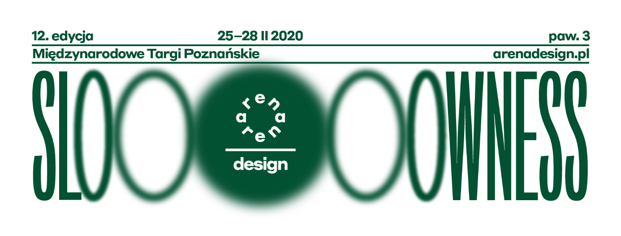

In the next decade, furniture production in Poland may double, reaching a turnover of 100 million PLN. This success is at our fingertips. The recipe for the sector's development includes a 35% increase in production, 35% increase in imported materials as well as 40% increase in the importance of Polish furniture brands and design services. Therefore it is worth creating a modern and self-conscious image of Polish design - says Dr Eng Tomasz Wiktorski, Programme Director of the Brand Stage.

Brand Stage is a unique formula combining a platform for holding meetings and establishing relations with entrepreneurs, designers and analysts from the furniture industry, a think tank highlighting the latest trends in brand creation and development, and finally a space enabling direct contact with users and investors - visitors of ARENA DESIGN, Meble Polska and Home Decor.

What are the most important factors strengthening brand status? How to effectively shape corporate image? How to shape the message and communicate with the customer responsibly? How to create effective domestic and international promotion? How to attract foreign investors? Finally, how to build and maintain the brand's reputation? During four days of the Brand Stage, 21 panels will be held, attended by over 60 furniture experts, manufacturers, designers, scientists as well as journalists, marketing specialists, representatives of the Horeca sector and institutions related to education. From the broad opening - discussion inaugurating the Brand Stage, devoted to the brand of the furniture industry from the perspective of global challenges - through the analysis of the Polish sector's development potential, to a leap into the future and a glance at innovative solutions, the need for digitisation and the involvement of design in the idea of sustainable development. The Brand Stage shares not only a modern and multi-dimensional approach to the subject of brand building but also experience, which is equally important in this discussion. Therefore, the last section of the Stage will focus on returning to the times of childhood and trying to outline ways to support the creativity of future generations involved with design.

Participants of Brand Stage discussions will include: Jan Szynaka – President of the Szynaka Furniture Group and the Polish Chamber of Commerce of Furniture Manufacturers, Mauro Mammoli – President of the Federmobili Association (Italy), Dr Jan Kurth from the Association of the German Furniture Industry (VDM), Maciej Formanowicz – President of Forte Furniture Factories, Ewelina Wójcik – Board Member at Wójcik Meble, Prof Imke Lohmann from Chengdu University, Prof Jerzy Smardzewski – Head of the Furniture Department at the Faculty of Wood Technology at the Poznań University of Life Sciences, Prof Katarzyna Laskowska – Head of the Educational and Design Programmes and Industrial Cooperation Studio at the University of the Arts Poznań, Gheorge Marian Cristescu – President of the Polish Hotel Holding, Dr Sascha Peters from Haute Innovation – materials and technology specialist.

Held concurrently with ARENA DESIGN, during this year's edition of Meble Polska, the Annual General Meeting of Members of the International Alliance of Furnishing Publications (IAFP) will be held. It will be an excellent opportunity to introduce representatives of the most important media of the furniture industry from nearly 20 countries to the achievements of Polish design - also presented at ARENA DESIGN 2020.

This year's ARENA DESIGN will feature several exhibitions including: Resources 2. Slow materials, Designers of the Year 2020, TOP DESIGN award, AD ROOMS or Copy – Inspiration – Parallel Thought by #loveOriginal Association. Visitors will have an opportunity to become familiar with new exhibition programs presenting the most interesting works of Polish designers in dedicated zones: FORMS OF THE FUTURE - POLISH DESIGNERS ZONE and VISIONARIES OF POLISH DESIGN. Lectures held as part of AD Talks will feature: Michael Anastassiades, Torbjørn Anderssen, Carole Baijings, Jan Boelen, Maddalena Casadei, Giulio Ridolfo and Seetal Solanki.

For a detailed programme of BRANDS STAGE go to: www.arenadesign.pl/pl/strefy/scena-marki/
For a detailed programme of AD TALKS go to:
Details: www.arenadesign.pl

ARENA DESIGN
Międzynarodowe Targi Poznańskie, Hall 3
25-28 February 2020
Głogowska 14
60-734 Poznań
TICKETS:
Industry representatives (designers, architects) - free admission after registration
Students, graduates of design, architecture, interior design - 10-20 zł
Visitors not related to the industry - 30 zł

Media Partners: Vogue Polska, Elle Decoration

Honorary Patronage: Marshal of the Wielkopolska Region Marek Woźniak, Honorary Patronage of the Mayor of Poznań

Media Partners: Wysokie Obcasy, Label Magazine, Design Alive, KRAFT, WhiteMAD, Biznes Meble, Architektura&Biznes, Homebook Design, Pomysł na Wnętrze, Magazif, Urządzamy.pl
Editorial Patronage: WP.PL

MEDIA SERVICE
SZUSTOW. Kultura i Komunikacja

Contact:

Konrad Fleśman

mob: +48 693 026 427

konrad.flesman@grupamtp.pl

Ewa Wysocka – Marketing and Public Relations

mob: +48 691 029 067

ewa.wysocka@grupamtp.pl

Media Contact:

Majka Duczyńska

Indyjska 19, Warsaw

669 663 966

m.duczynska@szustow.com

